# Question 1:

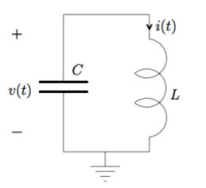

From the prelab we were able to find the following equations for v(t) and i(t):

$$v(t) = -ω_{0}L(I_{0}sin(ωt + φ)$$

$$i(t) = I_{0}cos(ωt + φ)$$

Setting the initial conditions for the capacitor and the inductor to 0 we see no activity in the voltage and the current traces when they are plotted. As the initial conditions we required before the lab both expect an initial condition that is a non-zero value to obtain a non-zero value for $I_{C} and I_{L}$, this would be the result we expected.

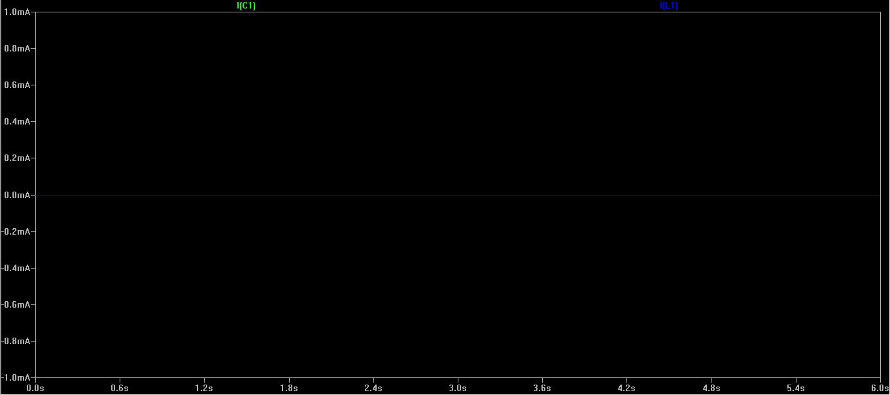

After setting the initial conditions, SPICE produced the graph shown. It shows an oscillation between a positive and negative voltage. The voltage peaks at 10 and -10 volts. The current peaks at around 1.6 and -1.6 amps. Again this is as expected if we plug in those values into the formulae we produced in the prelab. The voltage and current do not decay away as there isn’t a resistance present. The current and voltage also appear to be out of phase. This is due to the inductor, which causes a lagging effect on the current with respect to the voltage across it. Also as the voltage and current are being measured in the opposite direction (minus sign) and one is a sinusoidal and the other is cosinusoidal wave, that is why they appear to be non-inverted.

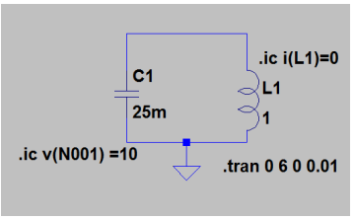

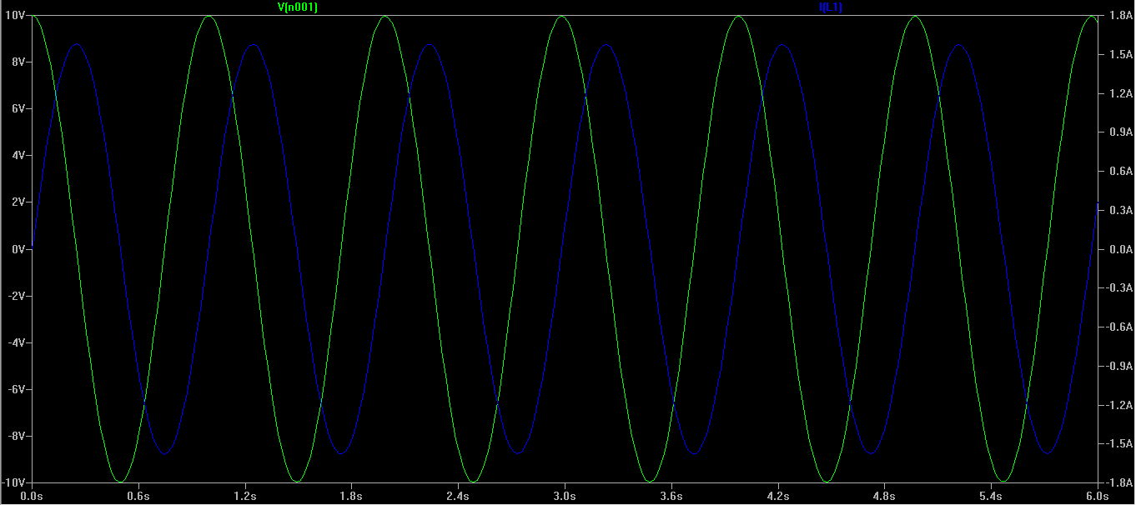

Without setting initial conditions for our inductor, the circuit does not have the relevant information needed to simulate the circuit and so SPICE will generate strange results. SPICE simulated 63 kilovolts and 10 kilo amps. Obviously this is not a realistic result. These results prove why one must be cautious and always include initial conditions for all circuit elements when using a circuit simulator like SPICE.  
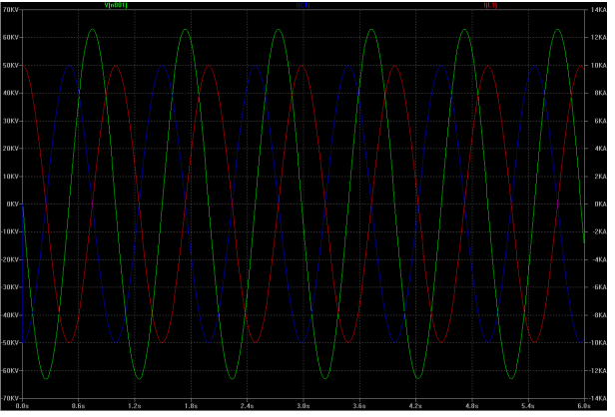

# Question 2:

With the resistor in place, the current and voltage decays to almost 0 over the course of a few seconds, this is called damping. It is due to energy being dissipated over time through the resistor. After approximately 5 seconds we see it reaches an almost steady state. The speed of the decay depends on the magnitude of the resistance of the resistor. Furthermore there would also be resistive elements to our other circuit elements which are not taken into account here. The graph plotting this decay of our RLC circuit can be seen below.

At t=2 seconds Voltage = 637.05 mV Current = -22.478 mA

At t=6 seconds Voltage = 5.39 mV Current = -437 $μ$ A

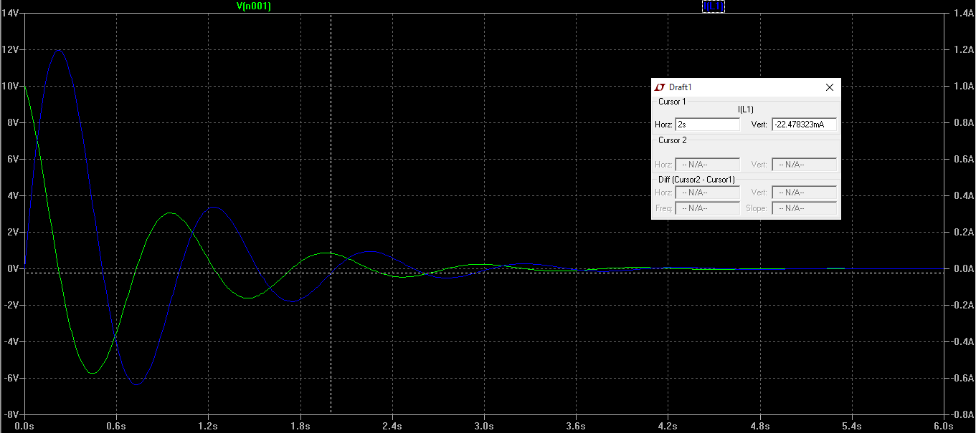

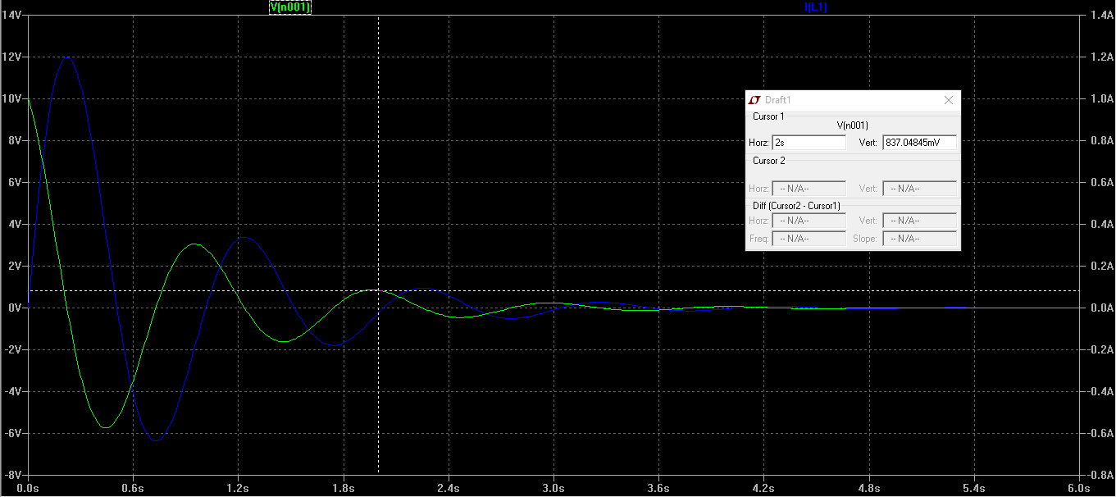

From the prelab we were able to obtain the following equations for $v(n+1)$ and for $i_{L}(n+1)$. :

$$v\left(n+1\right)=\frac{(v\left(n\right)\left(-G+G_{C}+G_{L}\right)-2\left(i_{L}\left(n\right)\right)}{G+G_{C}+G_{L}}$$

$$i_{L}\left(n+1\right)=v\left(n+1\right)G_{L}+G_{L}v\left(n\right)+i_{L}(n)$$

These equations were obtained using the trapezoidal rule.

When we simulated the pre lab calculations using the code given to us for MATLAB we found that it approximated the spice simulation quite well. MATLAB iterated through the data obtained from SPICE. The initial error is due to a difference in sample rate. For the MATLAB calculation we used h=0.1 while for our SPICE simulation we used 0.01.

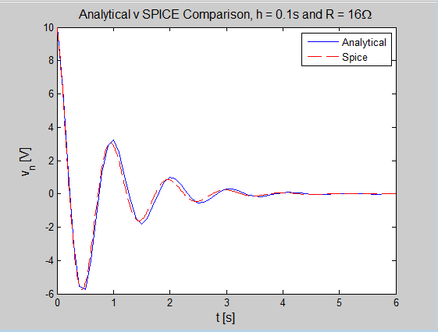

We then changed the time step to 0.5s and saw that the MATLAB approximation was quite drastically different to our SPICE and didn’t accurately simulate our circuit. While it did decay at the same rate the graph had a very different shape as seen below.

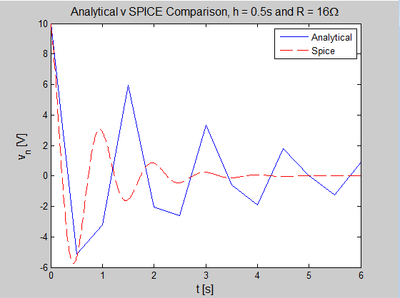

Then when we changed the time step to 0.01, the same time step that we used in SPICE and the two graphs matches perfectly. This shows that by decreasing h to a small value (i.e. 0.01 s), the equation produces a higher resolution, and therefore a more accurate output for the voltage of the circuit. On the other hand, by making h small, the software needs to do more calculations so this could take a very long time for very high precision outputs.

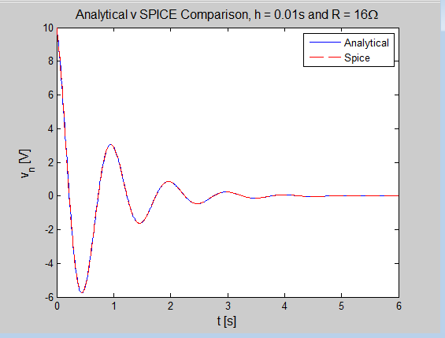

By changing the value of R we see a different rate of voltage and current dissipation. When we set it to 500 Ohms we see a much reduced rate of decay compared to our earlier, smaller value of R. This is due to a smaller amount of energy dissipated through the resistor.

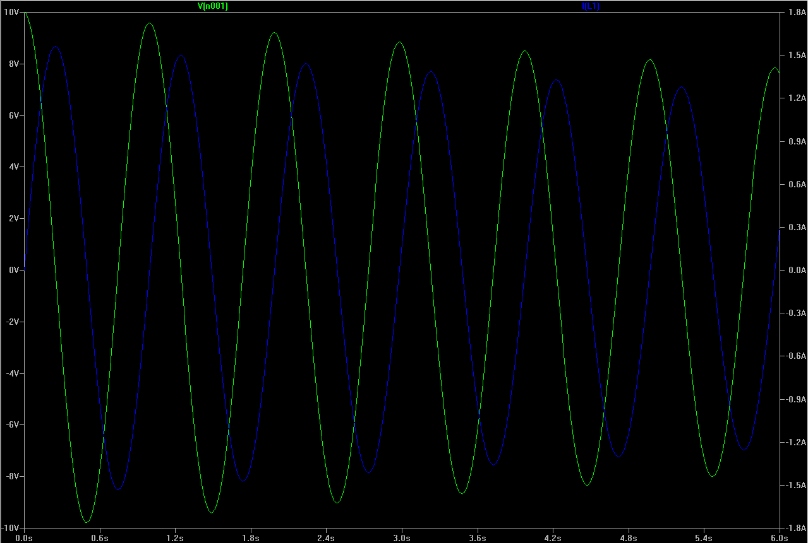  
500 ohm

By reducing the value of R to 500 mOhms we see an incredibly quick decay. This shows that R has a major effect on the damping characteristic of the circuit. The larger R value you use the less of a damping result you obtain. The opposite is true as R approaches 0.

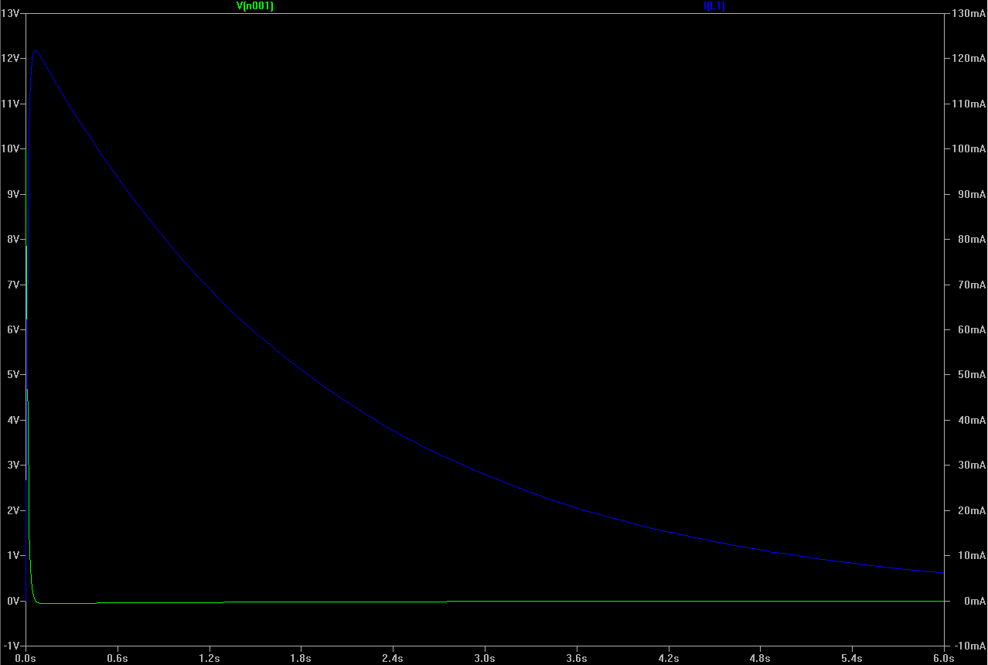  
500 mOhm

# Question 3

In our case, the $α$ and $β$ values are 8 and 1 respectively. Therefore our voltage source is 9v and the controlling current source has a current of 25mA. From our values for $α$ and $β$ we obtain a voltage for V1 of 9V and a gain for the CCCS of 1.

We created the following SPICE netlist to represent our circuit:

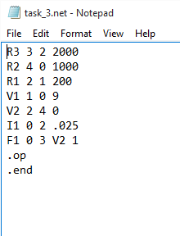

The netlist must differ slightly from the exact circuit given as SPICE requires a 0V voltage source to evaluate any controlling source in the circuit. This voltage source was added to the netlist and can be seen in the MNA matrix below.

The matrix obtained using the check_MNA.exe program that we were provided for the lab and this matches perfectly to the matrix we obtained in our prelab. We also identified all of the stamos in our matrix which represent all of our different circuit elements in our circuit. The stamps are outlined in our prelab matrix. The following is the output of our check_MNA.exe.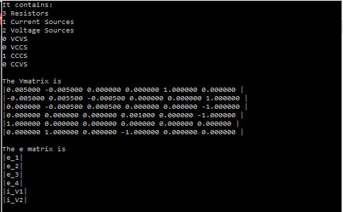  
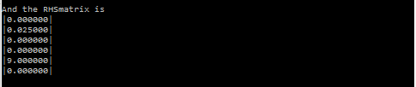

The following are our node voltages and currents for our netlist.

Our node voltages are : V1 9V  
 V2 14V  
 V3 42V  
 V4 14V

We see that our V4 and V2 are the same as the only difference between them is our 0V source entered for simulation purposes.

Our controlling current is 14mA.

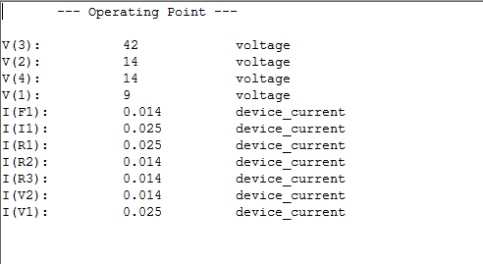

SPICE calculates currents by calculating the node voltages and then multiplying them by the conductance similar to the way we did it for our Prelab.